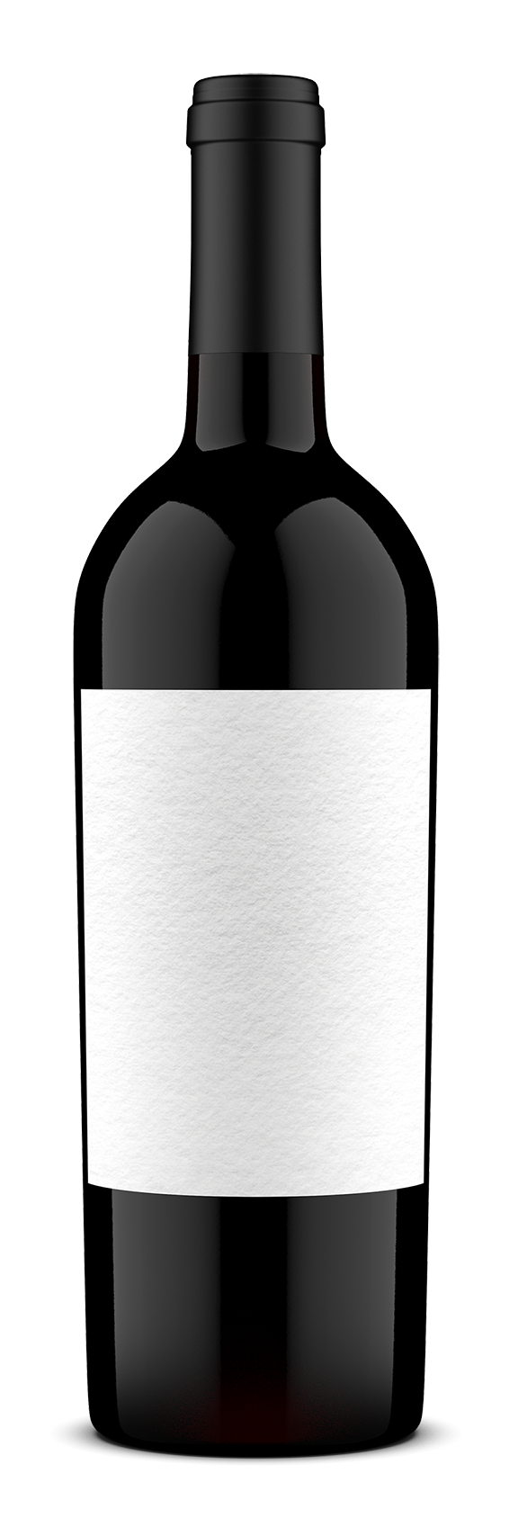 | Wine: Cabernet Sauvignon 2015 | Vineyard: Particular vineyard
 | Cellar notes: Enjoy by 2020 | Notes: Only 232 cases produced
 | Fruit: Black cherry, black currant and blackberry  Other: Black pepper, tobacco, licorice, vanilla and violet  Aging: 12 months French oak | Food pairing: Braised beef short ribs, garlic chicken wings, tomato roasted garlic and goat cheese tart  Degustation: Open 2 hours before drinking, use a decanter
 | Tanin: Medium  Acidity: Medium | Did you know: Cabernet Day is held on the Thursday before Labor day.

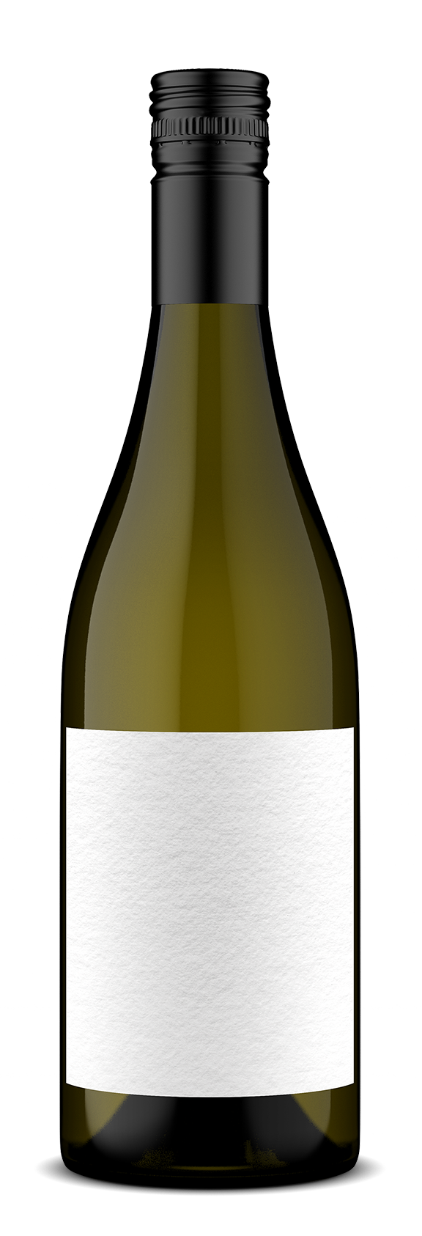 | Wine: Chardonnay 2016 | Vineyard: Particular vineyard
 | Cellar notes: Enjoy by end of 2018 | Notes: A particular favorite!
 | Fruit: Lemon and green apple  Other: Orange peel and honey  Aging: Left to mature on the lees for 1 month (batonnage technique) | Food pairing: Tuscan bean soup with squash and kale, Dijon-tarragon cream chicken, strawberry and rosemary tarte tatin  Degustation: Chill beforehand
 | Tanin: Medium  Acidity: Medium-high | Did you know: Our winery first started producing this wine in 1982.

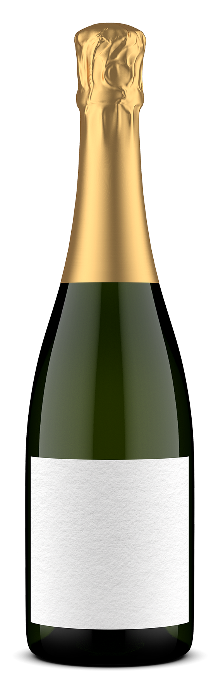 | Wine: Blanc de Blancs NV | Vineyard: Particular vineyard
 | Cellar notes: Enjoy by 2019 | Notes: Perfect for celebrations of any kind
 | Fruit: Fresh with dominant notes of citrus and exotic fruits  Other: Touch of jasmine, white peaches and pink peppercorns  Aging: 18 months | Food pairing: Poached eggs with parmesan and smoked salmon toasts, mustard-glazed black cod with fingerlings, chilled peach soup  Degustation: Chill beforehand, keep in ice-bucket in between pourings
 | Tanin: Medium  Acidity: High | Did you know: This is a traditional blend of multiple varieties and vintages of wine.

